 Gloria Nikki Bell
February 17, 2015 · Edited ·

Allowed on Timeline

No Quarter! ......2015...cr 2015
Updated on Sunday

Carmagnole, a short waisted jacket favored by French revolutionaries named after the Italian town of Carmagnola, which they captured in1792....this i did not know!...just wanted to see what the name of my ship, the Carmagnole meant....so...there it is! :D............okay, history lesson over for the day! lol!



it's a snowy day so i think i'll meet my hubby on the high seas!!!...all set; have my Fleur-De-Lis on for "good luck" ;D

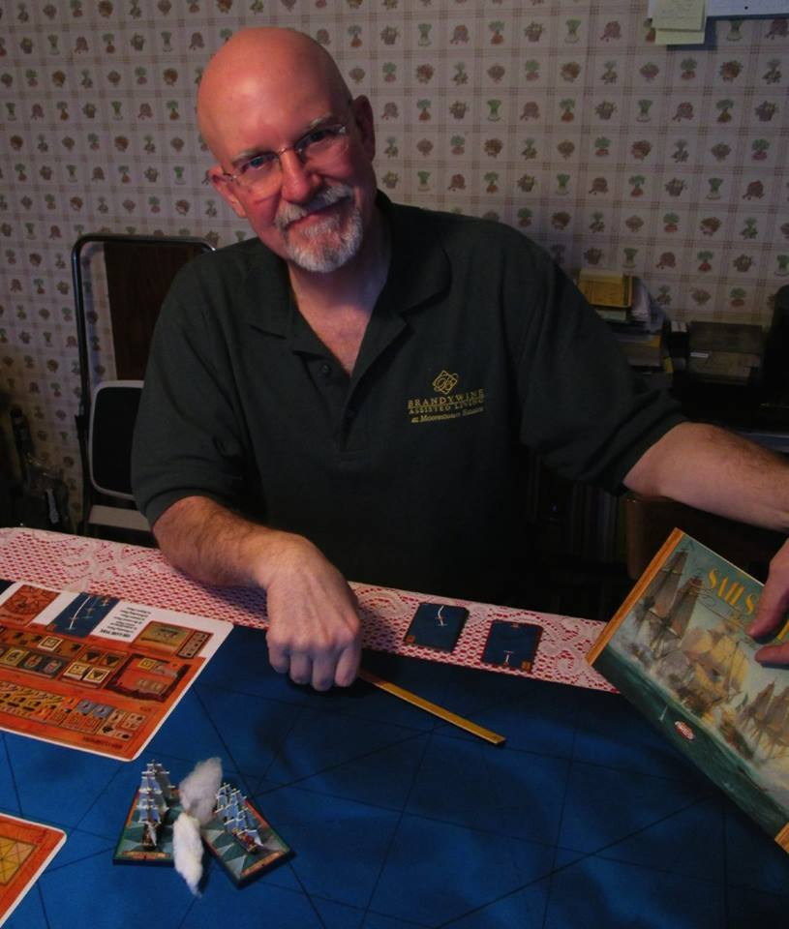

"... i'm your captain"

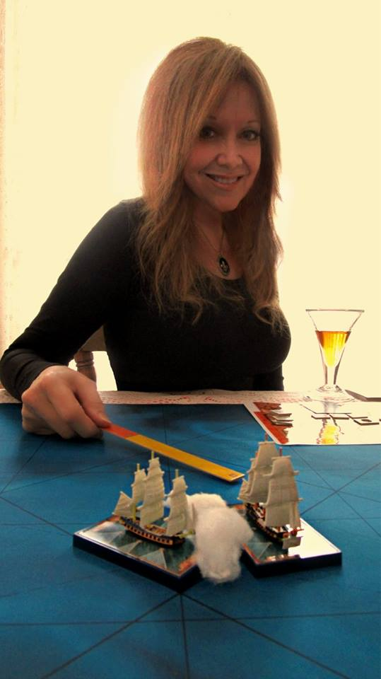

i played this game once before but today i'm learning how to use my crew and how to deal with damage. wow...there's a lot to think about, but it's ALSO a lot of fun!!!...lol!

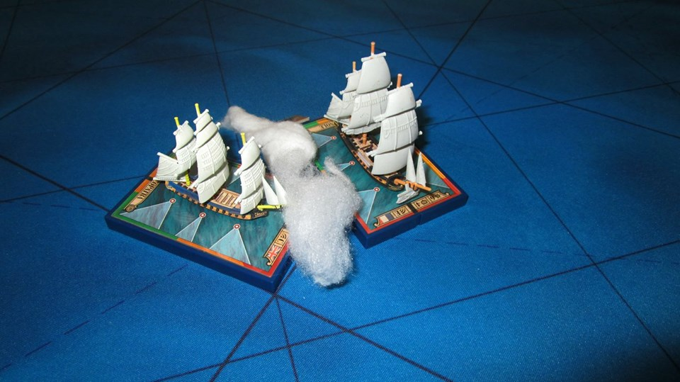

round 1...after dueling for a few turns, my Carmagnole began taking on serious water sooo...i went to full sail, collided with the Cleopatra and got our ships entangled.....no wimp here!

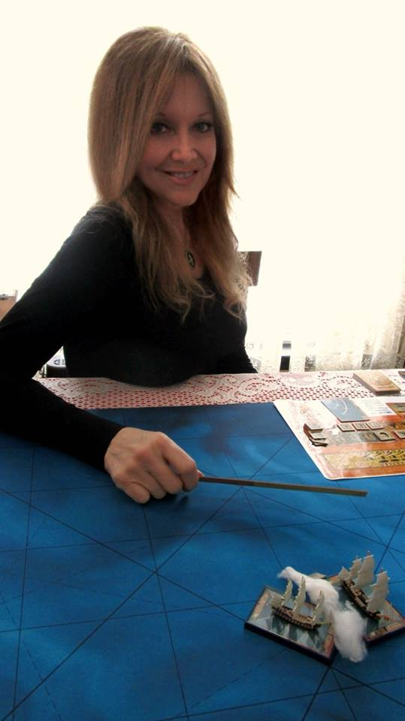

...oops!...did i do that? lol! well while i'm here i might as well fire a broadside...

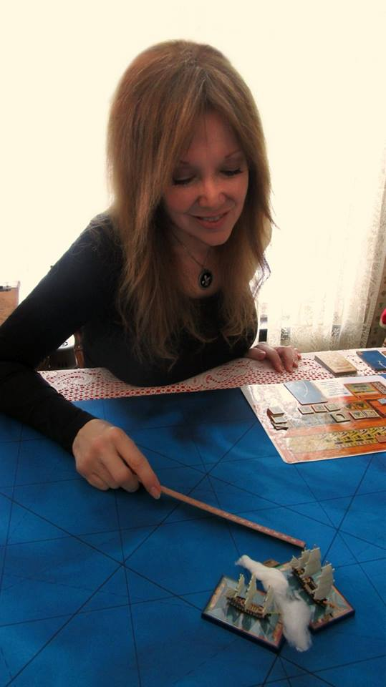

...aaaaand, i might as well have my marines fire on the enemy deck with their muskets...yes, that's the ticket! grin emoticon!!!

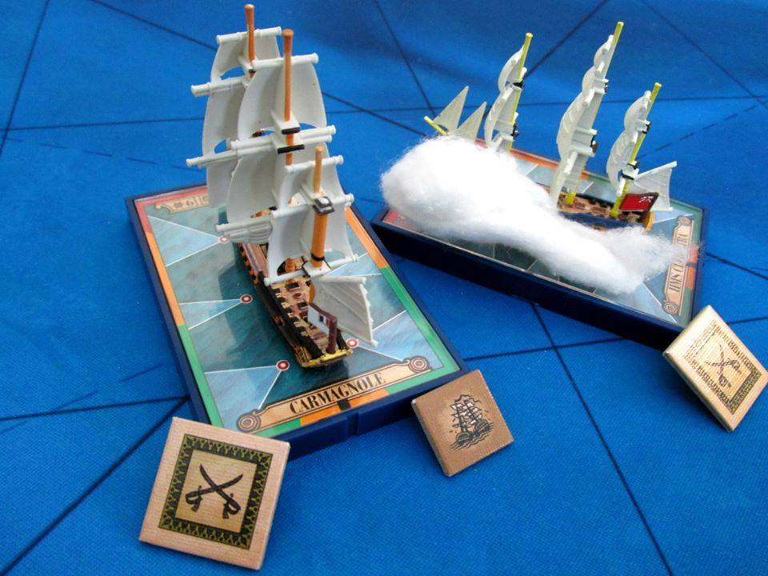

...and THEN i might as well overwhelm the Cleopatra's crew and take over the ship before MINE sinks! lol!!!....Bonzaiiiiii !!!

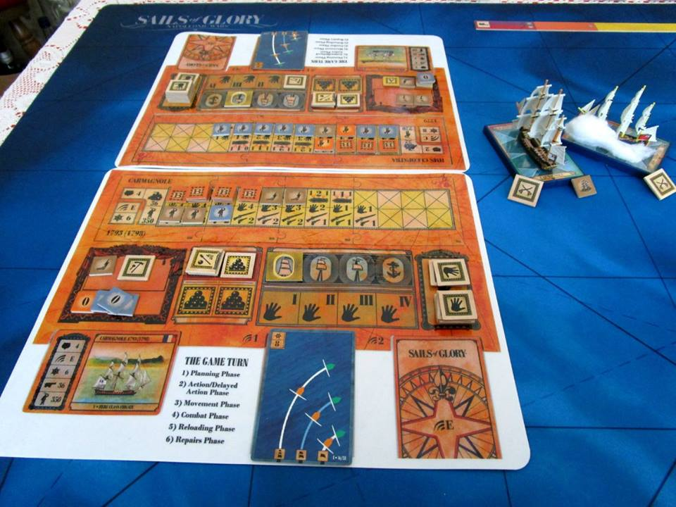

round 1 of three goes to the French...yesss! go me!!!

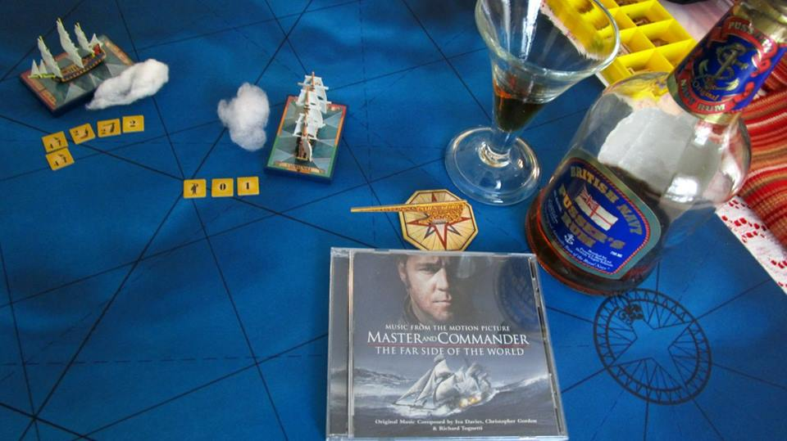

...........everything to create the proper mood..."Master and Commander" and Pusser's British Navy rum...i had to giggle inside thinking that these little cannons were firing ...cotton!!! yikes!!! :DDD

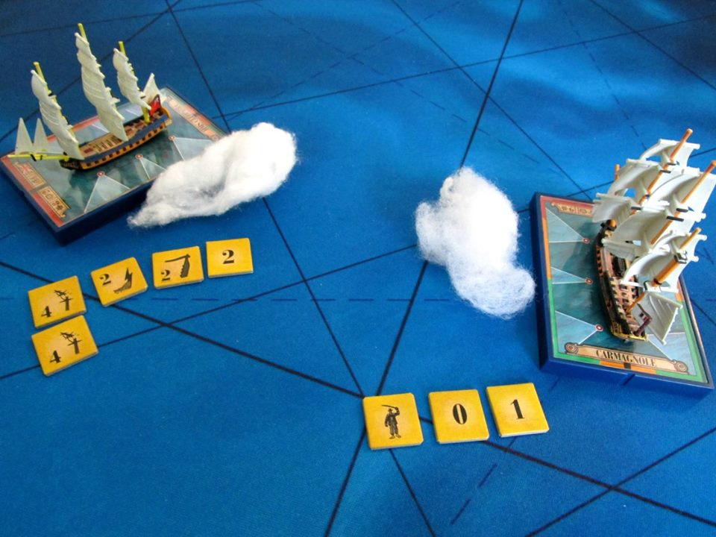

round 2...turn 3...clipping her stern with a lucky long shot which damaged Cleopatra's rudder, i swung hard to starboard and blasted her with a devastating initial broadside from my port guns, inflicting even more damage. i barely suffered anything in return...not looking good for the Brits...yay!!!

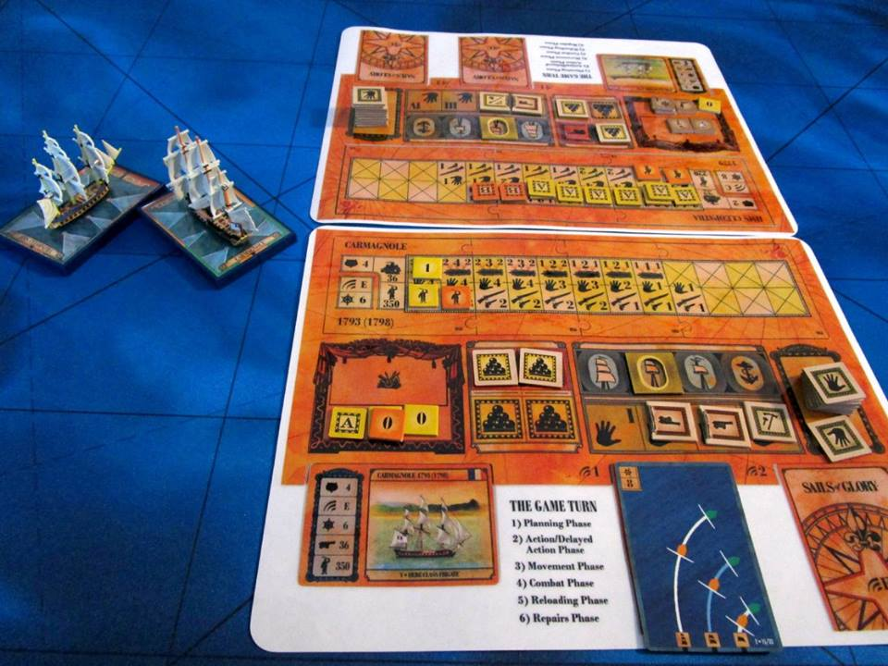

...after a few turns of maneuvering i finally closed with the crippled Cleopatra and she struck her colors...round 2...French again!!!

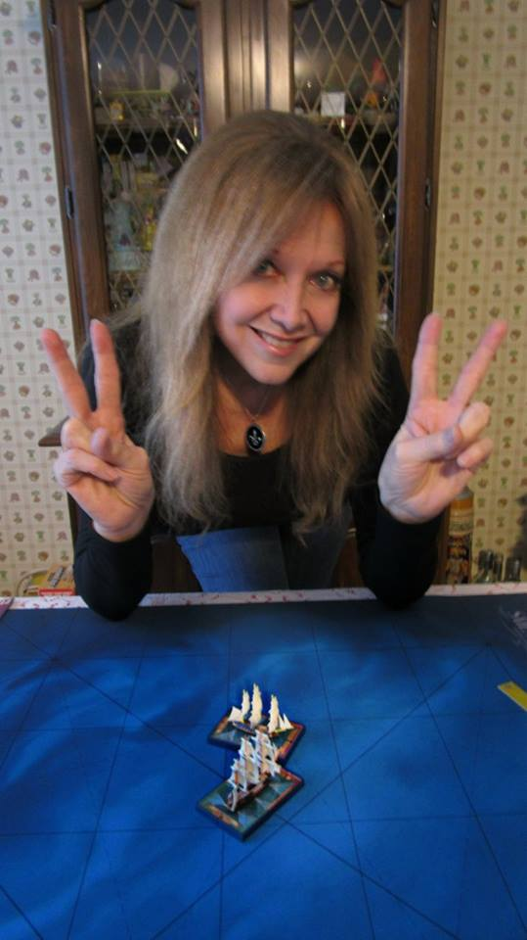

no need for round 3...victory...2 for 2...lol!!

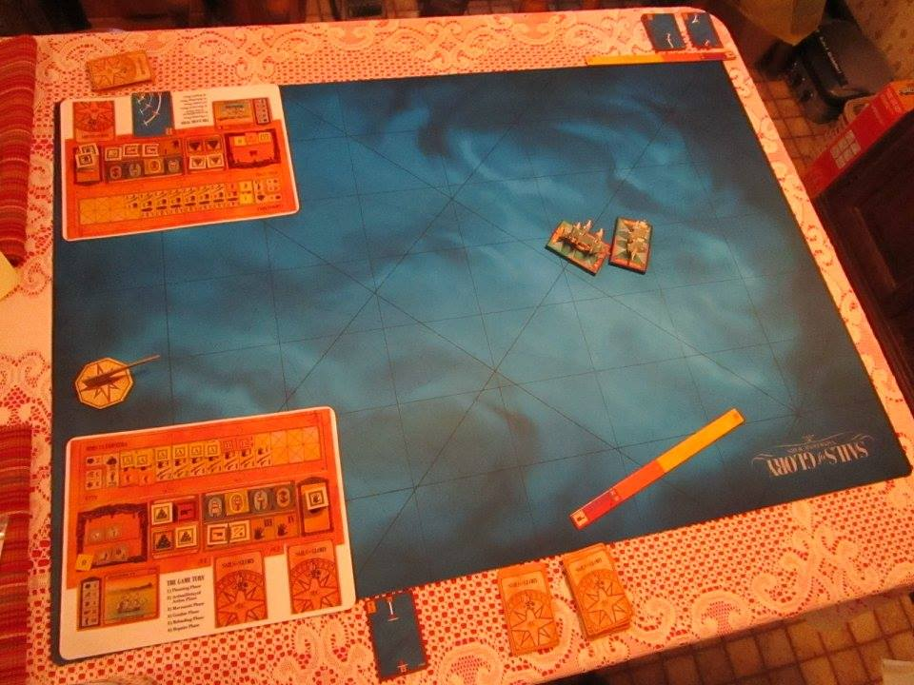

it's a big ocean...and a lot more ships to capture! lol!!!

