Sails of Glory: French Flags, Ensigns and Pennants

National Flag/Ensign
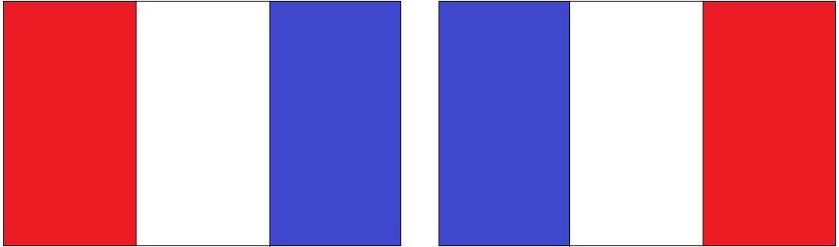

Red Ensign


White Ensign


Blue Ensign


Pennant

War Ensign and Admiral’s Flag pre Revolution


Naval War Flag 1790-1794


(Copyright Brad Golding 2015)

